Sponsorship Package 2017

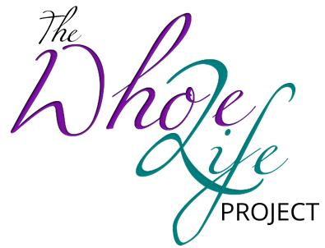

A Non-Profit Organization

The Whole Life Project, Inc.
Paula Cook, Executive Director
www.thewholelifeproject.org

The Whole Life Project LLC
SPONSORSHIP PACKAGE 2017-2018

WHO WE ARE
The Whole Life Project LLC is an organization that addresses and supports women and young girls live a whole life in mind, body and spirit. Our objective is to provide wholesome solutions to issues impacting their lives. We host events, conferences and forums that address and promote good health in diet and exercise, etiquette programs and self image training for youth, prayer services and topic specific meetings for women overcoming brokenness for spiritual support. Through collaborations with other community organizations, we hope to empower women and young girls to believe that they are valuable and that loving themselves is a good thing for a successful and whole life.

OUR GOAL
Our Goal is to raise $100,000 to open a facility to host all our events under one roof and to develop a program that will serve as a healing center for women with undue hardship, a youth center, office space for small businesses and resource center for the residents of the community.

_____________________________ SPONSORSHIP LEVELS __________________________________

A-LIST SPONSOR
An A-List sponsor is company/organization that will sponsor our project with a monetary donation of $5000.00. Your company/organization will be a consistent presence in our events and projects for the whole year. A-List Sponsorship includes the following incentives;

- Your company will be given a video interview to be featured on our website (you will receive a personal copy)
- Your company may supply a two minute video to be featured during all our events before and during intermission
- Your logo and business information will be featured on The Whole Life Project organization T-shirts
- Your logo and business information will be featured on the following publications (programs, flyers, step and repeat Banners)
- VIP Free Admission to events for two (2)
- Vendor Space at all events

MERCHANT SPONSOR
A Merchant sponsor is company/organization that will sponsor our project with a product donation of $1000.00. Your company/organization will be a consistent presence in our events and projects for the whole year. Merchant Sponsorship includes the following incentives;

- Company and product review video to be played at two (2) Whole Life Project events
- Your logo and business information will be featured on the following publications (programs and
step and repeat banners)
- VIP Free Admission for two (2) events
- Vendor space at two (2) events

5-STAR SPONSOR
A 5-STAR Sponsor is company/organization that will sponsor a specific event with a monetary donation or product donation of $500.00. Your company/organization will be a consistent presence during the event. 5-Star Sponsorship includes the following incentives;
- Your logo and business information will be featured on the event publications (programs, flyers,
Tickets, provided marketing material has not already printed)
- VIP Free Admission to the event
- Acknowledgement during event intermission if applicable or comparable agreement
- Vendor space at event

SPONSORSHIP DEADLINES
The Whole Life Project Inc, Sponsorship Year is parallel with the calendar school year which puts our dates for funds and products from A-List Sponsor more beneficial before the school winter break in December. The Merchant and 5-Start Sponsors are appreciated 30 days prior of event for planning and preparation. Having your contribution in on time will also ensure that your company info and other incentives will be managed in a timely manner.

Submit the following to thewholelifeproject@outlook.com
- Logo
- Social Media Links
- Website
- Picture (Optional)

Payments are made to The Whole Life Project, Inc.

CONTACT US
For additional Information on registering your company for sponsorship, press release, or any questions or concerns, please give us a call to Paula Cook, 678-301-0782.

